ENCOUNTERING CONFLICT 2015

Frustrated residents flag 'madcap' plan to turn their suburb into sovereign nation
By Helen Vines
Updated Mon at 11:32amMon 4 May 2015, 11:32am
Photo: The flag represents the nearby RAAF base and blue and white colour workers, with the Southern Cross in the middle. (ABC News)
Map: Point Cook 3030
A group of frustrated residents from Point Cook, in Melbourne's west, want to turn their fast-growing suburb into a sovereign nation.
The residents say they are sick of being ignored by governments of all levels and are ready to secede from Australia.
Local resident Tony Hooper started the push for independence and was the first to admit it was a wild idea.
"It's madcap, it's crazy, but the situation we're dealing with is crazy to begin with," he said.
If the politicians can't hear a cry for help and can't say alright, let's put aside our petty differences and actually start representing the people, then what sort of country have we got?
Tony Hooper, Point Cook resident
The Wyndham City Council area, which includes Point Cook, is growing rapidly.
Eighty babies are born each week, 3,000 new dwellings are built each year and annual population growth exceeds 10,000.
Mr Hooper said there was a lack of local jobs, police and high schools, along with poor access to public transport and congested roads.
He started an online petition calling for a referendum on Point Cook seceding.
The petition has already gathered more than 300 signatures.
Supporters have even designed a new flag for the fledgling nation.
It includes a dark blue stripe for the nearby RAAF base, a light blue stripe for the area's blue collar workers and a white stripe for white collar workers, with a southern cross in the middle.

Residents want Prince Harry to head 'new nation'
They have even thought of who they would like to be their head of state.
"I'd talk to Prince Harry and say 'You're limited with where you're going with the Royal family, why don't you join us?' " said Mr Hooper.
John Farnham's popular tune "You're The Voice" could be the national anthem, he said.
The new nation's revenue could come from removing payroll and land tax and "Google would certainly be looking at a new tax regime" in Point Cook, Mr Hooper said.
Locals have mixed views on becoming an independent nation.
One said they thought it was a "brilliant idea" while another thought the suburb was too small to be its own country.
The Mayor of Wyndham City Council, Peter Maynard, said council understood and sympathised with the frustrations expressed by Point Cook residents and those in other growth areas within the municipality.
"These frustrations are the result of the unrelenting residential growth, which continues to be approved by the state and federal governments, whilst infrastructure and services fail to keep up with this growth," he said.
"Point Cook is in need of arterial road duplications, additional bus services, new schools and increased commuter parking.
"Local hospital and police services are also severely overstretched."
Mr Maynard said those issues were the responsibility of the State Government.
"In turn, the State Government is very reliant on getting fair funding from the Federal Government," the Councillor Maynard said.
"These conditions have become so bad that council has recently resolved to offer a contribution of $3 million towards a state government road that connects to the freeway.
"This is not a problem confined to Point Cook, or indeed growth areas in Wyndham.
"It is a problem in all growth areas and it is a problem for all levels of government."

Premier says plans are 'a bit ambitious'
Victorian Premier Daniel Andrews is sceptical about independence, but was open to listening.
"I don't want to see any community feeling that they are not being listened to," Mr Andrews said.
"As for their plans, they're probably a bit ambitious."
Mr Hooper said the secession plan was really a cry for help from the area, a bold grab for attention.
"If the politicians can't hear a cry for help and can't say 'all right, let's put aside our petty differences and actually start representing the people', then what sort of country have we got," he asked.
What are the odds of a new nation within Australia going ahead?
"Between zero and Buckley's and none," Mr Hooper said.
But that does not mean he will stop pushing for a better deal for Point Cook.
http://www.abc.net.au/news/2015-04-28/melbourne-residents-plan-to-turn-suburb-into-sovereign-nation/6428576

By William Blake 1757–1827William Blake
My mother groand! my father wept.
Into the dangerous world I leapt:
Helpless, naked, piping loud;
Like a fiend hid in a cloud.

Struggling in my fathers hands:
Striving against my swaddling bands:
Bound and weary I thought best
To sulk upon my mothers breast.

http://www.poetryfoundation.org/poem/175221
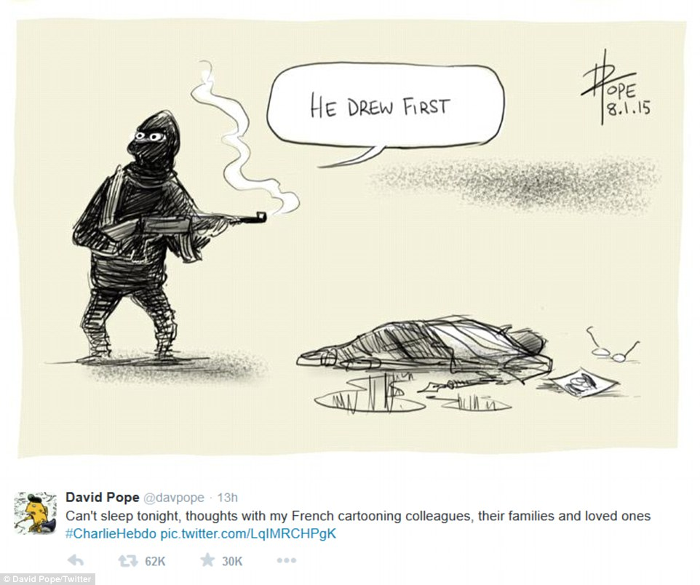

David Pope
Cartoonists from around the world have gone to their drawing boards to pay tribute to those killed in the Charlie Hebdo shooting on Jan. 7, 2015. "Can't sleep tonight, thoughts with my French cartooning colleagues, their families and loved ones #CharlieHebdo," cartoonist David Pope captioned this drawing on Twitter in response to the attack on the French satirical newspaper which left 12 people dead.
http://www.nydailynews.com/news/cartoonists-world-respond-charlie-hebdo-attack-gallery-1.2070944

By Robert Frost 1874–1963
Some say the world will end in fire,
Some say in ice.
From what I’ve tasted of desire
I hold with those who favor fire.
But if it had to perish twice,
I think I know enough of hate
To say that for destruction ice
Is also great
And would suffice.
http://www.poetryfoundation.org/poem/173527

Why ISIS Is So Terrifyingly Effective at Seducing New Recruits
By Jesse Singal Follow @jessesingal
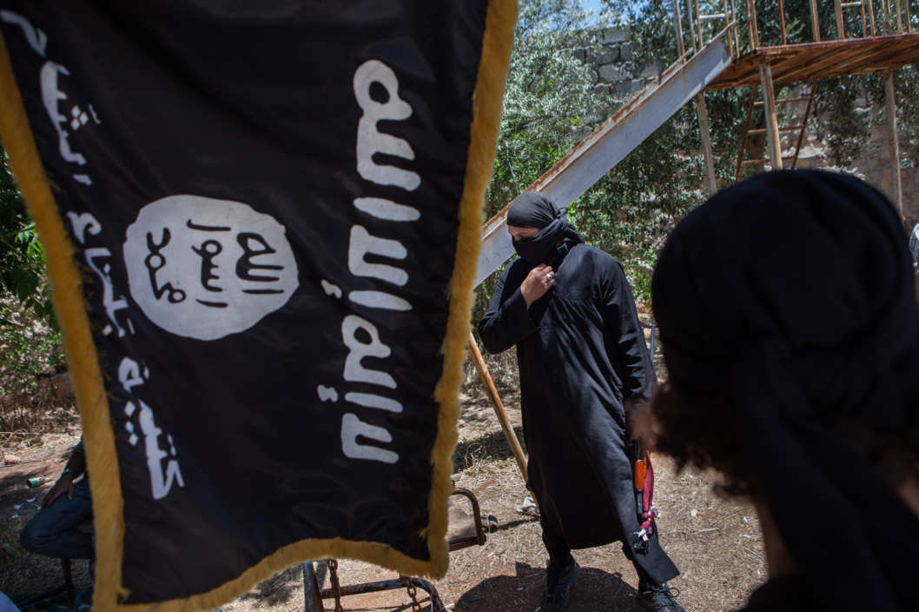
Photo: Daniel Leal-Olivas/Corbis
The world has watched in horror as the Islamic State, an ultra-hardline militant Sunni group, has conquered large swaths of Syria and Iraq, effortlessly rolling through Iraq's United States–trained and –supplied army in the process. IS, which was allied with Al Qaeda before a rupture that can be partially attributed to the former's flagrant disregard for human rights, has effectively erased the border between Iraq and Syria as part of its stated goal of bringing about a new Islamic Caliphate.
Part of the reason IS (which is still commonly referred to by its old name, ISIS, for Islamic State of Iraq and Syria) has made such shocking progress toward this far-fetched goal is the enthusiasm with which would-be jihadists from all around the world are flocking to the group to fight in Syria and Iraq.
Science of Us spoke with John Horgan, a psychologist at UMass-Lowell who specializes in terrorism and who has interviewed members of a wide variety of terrorist groups, about IS’s appeal, the group's slick media efforts, and what, if anything, can be done to slow its rising influence and accompanying territorial gains.
So who is the sort of person who joins a group like ISIS?
Looking across groups, whether it’s ISIS, IRA, Al Qaeda, you name it, we know for a fact that there’s no one single pathway to terrorism, even within specific groups, let alone across them. We’ve got lots of evidence that many different kinds of people become involved for many different kinds of reasons, and they end up doing many different kinds of things. Some become snipers, some become bombers, some become beheaders, for example.
The psychological literature has started to turn more and more away from the idea of trying to find a general model of involvement. We can definitely find broad risk factors for understanding how and why someone might become involved, though.
What’s the most common story, then?
People who join these groups are trying to find a path, to answer a call to something, which would basically mean that they’re doing something meaningful with their lives. That is a common denominator across the board. There’s typically a very, very strong moral pull. You often see recruits are driven by this passionate need to right some perceived wrong, to address some sort of injustice, to restore honor to those from whom it’s been taken.
Should we be more scared of ISIS than other, similar groups?
I’ve been studying terrorism for just about 20 years now, and what we’re seeing now is astonishing. ISIS truly is something different. It holds very, very broad appeal to both converts and natural-born Muslims alike. In the eyes of potential recruits, this is fantasy made reality. It’s everything that a would-be jihadist could have hoped for.
The one thing that this movement has done far more effectively than any other terrorist movement is that they’re masters at packaging the fantasy deal. ISIS has a reality distortion field that only Steve Jobs would have dreamt of. In the past, in the other movements I’ve studied, like the IRA, would-be terrorists have had to work very hard, psychologically speaking, to justify to themselves, their families, and others the path that they’re on. ISIS has made that journey of navigating the self-doubt much, much easier. The only real obstacle is actually getting there, geographically, and that certainly doesn’t seem to be slowing people down at all.
I think time will tell if ISIS’s staying power is something we should be worried about. But no terrorist group has ever had the numbers now that we’re seeing from ISIS. If they can effectively make strategies and figure out where they will be one year, two years, five years from now, then we will truly have something very dangerous and different on our hands.
Why is their appeal so much more effective than past appeals? What sets them over the top to make them so successful?
They’ve demonstrated results. They’re capturing cities, they’re flaunting weaponry. They’re creating a safe haven, or refuge, where they can live.
Does that create something of a snowball effect where the more weapons that they have, the more territory they have, the more their appeal grows, which brings in more people?
Absolutely, and it will also likely attract people from other movements. It allows ISIS to say, “Look, we’re the real deal.” For the most part, people have to be involved in terrorist groups for many years before they feel like they’ve achieved anything significant. ISIS is different.
What’s the difference between a fundamentalist and someone who joins ISIS? Are all ISIS members true fundamentalists?
Most radicals don’t act on their beliefs, let alone become involved in terrorism. For the most part ISIS is working very hard on trying to not just provide opportunities for people to go out there, but to say that they’re being honest and upfront about their message. They’re offering an opportunity for people to feel powerful. They’re making disillusioned, disaffected radicals feel like they’re doing something truly meaningful with their lives.
Looking at these selfies and YouTube videos, they offer an opportunity for people to take refuge in a group mentality, but also a chance for people to scowl back at their home countries and say, “Now I have the chance to speak my mind.” Not only that, but, “I can raise my kids in an environment that is free from that sort of corruption.” They’re not just offering a message, but they’re also offering a physical place where this fantasy can be lived out.
It sounds like there’s a population of people who would not have had a lot of convenient options to fight back against what they saw as unfair humiliations 10 or 20 years ago. Now they have a very appealing one.
Exactly. Like I said, the only obstacle is getting out there.
The post-9/11 conversation about terrorism has focused mostly on the concept of dispersed, loosely affiliated cells — a few young men coming together in London, say, planning a bombing, then dispersing. What ISIS is doing is very different, though.
Completely different. And that’s why I think we have to rethink a lot of our assumptions about terrorism — for example, the difference between terrorism and warfare and terrorism and insurgency. This is far more warlike, far more akin to a large-scale insurgent movement than a small-scale terrorism movement.
There’s a very different set of psychological demands associated with someone who’s trying to lay low in a Western city versus someone who’s involved in front-line fighting. This is the stuff that really attracts a far broader set of potential recruits because there isn’t a sense that they have to live a double life, which brings with it a lot of psychological demands.
So in other words, the kind of person who is eager to get an AK-47 and patrol Raqqa or some other part of Syria or Iraq, they might not overlap with the kind of person who would have the wherewithal to plan a bombing in a Western city?
A lot of people want to get involved in those kind of battles. In the past, the reality has been that you end up sitting around in a safe house being bored out of your mind. As a result, a lot of them become disillusioned and they end up trying to justify some pretty low-level, tawdry activity. I think those kinds of psychological difficulties are made far easier when you have a mass movement like this, when you have so many other like-minded individuals out there contributing.
http://nymag.com/scienceofus/2014/08/how-isis-seduces-new-recruits.html

Bali 9 executions: Andrew Chan's letter to the nephew he adored
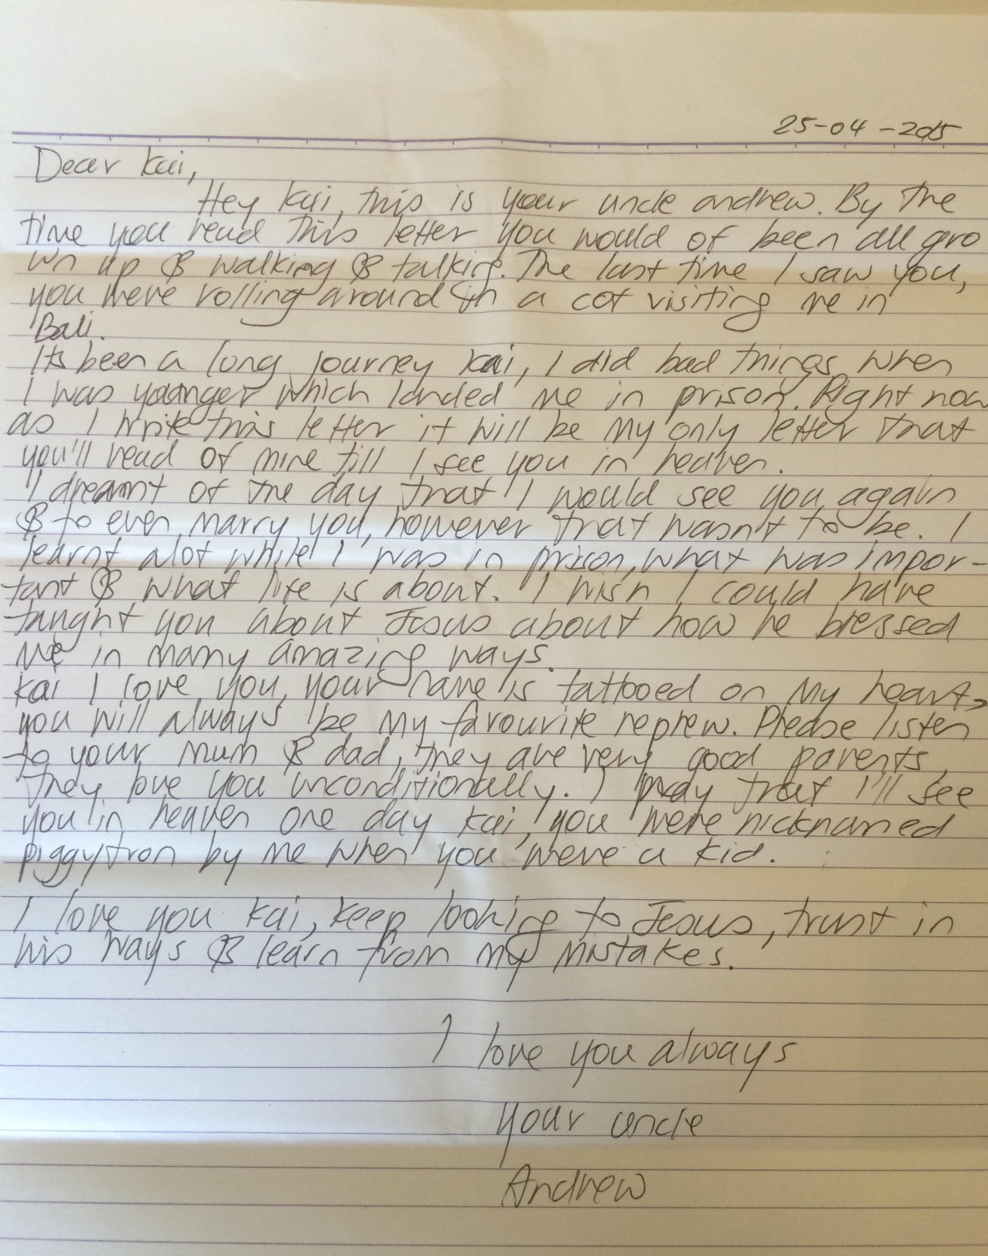
http://www.smh.com.au/world/bali-9-executions-andrew-chans-letter-to-the-nephew-he-adored-20150501-1mxxdl.html

Transcript of Julia Gillard's speech
Date October 10, 2012
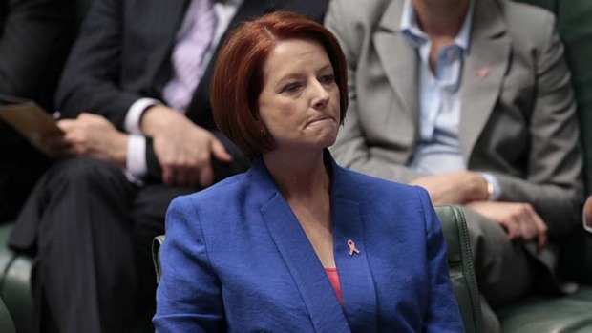
Julia Gillard made an impassioned speech against Tony Abbott's motion to remove Peter Slipper as Speaker. Photo: Andrew Meares
Thank you very much Deputy Speaker and I rise to oppose the motion moved by the Leader of the Opposition. And in so doing I say to the Leader of the Opposition I will not be lectured about sexism and misogyny by this man. I will not. And the Government will not be lectured about sexism and misogyny by this man. Not now, not ever.
The Leader of the Opposition says that people who hold sexist views and who are misogynists are not appropriate for high office. Well I hope the Leader of the Opposition has got a piece of paper and he is writing out his resignation. Because if he wants to know what misogyny looks like in modern Australia, he doesn't need a motion in the House of Representatives, he needs a mirror. That's what he needs.
Let's go through the Opposition Leader's repulsive double standards, repulsive double standards when it comes to misogyny and sexism. We are now supposed to take seriously that the Leader of the Opposition is offended by Mr Slipper's text messages, when this is the Leader of the Opposition who has said, and this was when he was a minister under the last government – not when he was a student, not when he was in high school – when he was a minister under the last government.
He has said, and I quote, in a discussion about women being under-represented in institutions of power in Australia, the interviewer was a man called Stavros. The Leader of the Opposition says “If it's true, Stavros, that men have more power generally speaking than women, is that a bad thing?”
And then a discussion ensues, and another person says “I want my daughter to have as much opportunity as my son.” To which the Leader of the Opposition says “Yeah, I completely agree, but what if men are by physiology or temperament, more adapted to exercise authority or to issue command?”
Then ensues another discussion about women's role in modern society, and the other person participating in the discussion says “I think it's very hard to deny that there is an underrepresentation of women,” to which the Leader of the Opposition says, “But now, there's an assumption that this is a bad thing.”
This is the man from whom we're supposed to take lectures about sexism. And then of course it goes on. I was very offended personally when the Leader of the Opposition, as Minister of Health, said, and I quote, “Abortion is the easy way out.” I was very personally offended by those comments. You said that in March 2004, I suggest you check the records.
I was also very offended on behalf of the women of Australia when in the course of this carbon pricing campaign, the Leader of the Opposition said “What the housewives of Australia need to understand as they do the ironing…” Thank you for that painting of women's roles in modern Australia.
And then of course, I was offended too by the sexism, by the misogyny of the Leader of the Opposition catcalling across this table at me as I sit here as Prime Minister, “If the Prime Minister wants to, politically speaking, make an honest woman of herself…”, something that would never have been said to any man sitting in this chair. I was offended when the Leader of the Opposition went outside in the front of Parliament and stood next to a sign that said “Ditch the witch.”
I was offended when the Leader of the Opposition stood next to a sign that described me as a man's bitch. I was offended by those things. Misogyny, sexism, every day from this Leader of the Opposition. Every day in every way, across the time the Leader of the Opposition has sat in that chair and I've sat in this chair, that is all we have heard from him.
And now, the Leader of the Opposition wants to be taken seriously, apparently he's woken up after this track record and all of these statements, and he's woken up and he's gone “Oh dear, there's this thing called sexism, oh my lords, there's this thing called misogyny. Now who's one of them? Oh, the Speaker must be because that suits my political purpose.”
Doesn't turn a hair about any of his past statements, doesn't walk into this Parliament and apologise to the women of Australia. Doesn't walk into this Parliament and apologise to me for the things that have come out of his mouth. But now seeks to use this as a battering ram against someone else.
Well this kind of hypocrisy must not be tolerated, which is why this motion from the Leader of the Opposition should not be taken seriously.
And then second, the Leader of the Opposition is always wonderful about walking into this Parliament and giving me and others a lecture about what they should take responsibility for.
Always wonderful about that – everything that I should take responsibility for, now apparently including the text messages of the Member for Fisher. Always keen to say how others should assume responsibility, particularly me.
Well can anybody remind me if the Leader of the Opposition has taken any responsibility for the conduct of the Sydney Young Liberals and the attendance at this event of members of his frontbench?
Has he taken any responsibility for the conduct of members of his political party and members of his frontbench who apparently when the most vile things were being said about my family, raised no voice of objection? Nobody walked out of the room; no-one walked up to Mr Jones and said that this was not acceptable.
Instead of course, it was all viewed as good fun until it was run in a Sunday newspaper and then the Leader of the Opposition and others started ducking for cover.
Big on lectures of responsibility, very light on accepting responsibility himself for the vile conduct of members of his political party.
Third, Deputy Speaker, why the Leader of the Opposition should not be taken seriously on this motion.
The Leader of the Opposition and the Deputy Leader of the Opposition have come into this place and have talked about the Member for Fisher. Well, let me remind the Opposition and the Leader of the opposition party about their track record and association with the Member for Fisher.
I remind them that the National Party preselected the Member for Fisher for the 1984 election, that the National Party preselected the Member for Fisher for the 1987 election, that the Liberals preselected Mr Slipper for the 1993 election, then the 1996 election, then the 1998 election, then for the 2001 election, then for the 2004 election, then for the 2007 election and then for the 2010 election.
And across these elections, Mr Slipper enjoyed the personal support of the Leader of the Opposition. I remind the Leader of the Opposition that on 28 September 2010, following the last election campaign, when Mr Slipper was elected as Deputy Speaker, the Leader of the Opposition at that stage said this, and I quote.
He referred to the Member for Maranoa, who was also elected to a position at the same time, and then went on as follows: “And the Member for Fisher will serve as a fine complement to the Member for Scullin in the chair. I believe that the Parliament will be well-served by the team which will occupy the chair in this chamber. I congratulate the Member for Fisher, who has been a friend of mine for a very long time, who has served this Parliament in many capacities with distinction.”
The words of the Leader of the Opposition on record, about his personal friendship with Mr [Slipper], and on record about his view about Mr Slipper's qualities and attributes to be the Speaker.
No walking away from those words, they were the statement of the Leader of the Opposition then. I remind the Leader of the Opposition, who now comes in here and speaks about apparently his inability to work with or talk to Mr Slipper. I remind the Leader of the Opposition he attended Mr Slipper's wedding.
Did he walk up to Mr Slipper in the middle of the service and say he was disgusted to be there? Was that the attitude he took? No, he attended that wedding as a friend.
The Leader of the Opposition keen to lecture others about what they ought to know or did know about Mr Slipper. Well with respect, I'd say to the Leader of the Opposition after a long personal association including attending Mr Slipper's wedding, it would be interesting to know whether the Leader of the Opposition was surprised by these text messages.
He's certainly in a position to speak more intimately about Mr Slipper than I am, and many other people in this Parliament, given this long personal association.
Then of course the Leader of the Opposition comes into this place and says, and I quote, “Every day the Prime Minister stands in this Parliament to defend this Speaker will be another day of shame for this Parliament, another day of shame for a government which should already have died of shame.”
Well can I indicate to the Leader of the Opposition the Government is not dying of shame, my father did not die of shame, what the Leader of the Opposition should be ashamed of is his performance in this Parliament and the sexism he brings with it. Now about the text messages that are on the public record or reported in the – that's a direct quote from the Leader of the Opposition so I suggest those groaning have a word with him.
On the conduct of Mr Slipper, and on the text messages that are in the public domain, I have seen the press reports of those text messages. I am offended by their content. I am offended by their content because I am always offended by sexism. I am offended by their content because I am always offended by statements that are anti-women.
I am offended by those things in the same way that I have been offended by things that the Leader of the Opposition has said, and no doubt will continue to say in the future. Because if this today was an exhibition of his new feminine side, well I don't think we've got much to look forward to in terms of changed conduct.
I am offended by those text messages. But I also believe, in terms of this Parliament making a decision about the speakership, that this Parliament should recognise that there is a court case in progress. That the judge has reserved his decision, that having waited for a number of months for the legal matters surrounding Mr Slipper to come to a conclusion, that this Parliament should see that conclusion.
I believe that is the appropriate path forward, and that people will then have an opportunity to make up their minds with the fullest information available to them.
But whenever people make up their minds about those questions, what I won't stand for, what I will never stand for is the Leader of the Opposition coming into this place and peddling a double standard. Peddling a standard for Mr Slipper he would not set for himself. Peddling a standard for Mr Slipper he has not set for other members of his frontbench.
Peddling a standard for Mr Slipper that has not been acquitted by the people who have been sent out to say the vilest and most revolting things like his former Shadow Parliamentary Secretary Senator Bernardi.
I will not ever see the Leader of the Opposition seek to impose his double standard on this Parliament. Sexism should always be unacceptable. We should conduct ourselves as it should always be unacceptable. The Leader of the Opposition says do something; well he could do something himself if he wants to deal with sexism in this Parliament.
He could change his behaviour, he could apologise for all his past statements, he could apologise for standing next to signs describing me as a witch and a bitch, terminology that is now objected to by the frontbench of the Opposition.
He could change a standard himself if he sought to do so. But we will see none of that from the Leader of the Opposition because on these questions he is incapable of change. Capable of double standards, but incapable of change. His double standards should not rule this Parliament.
Good sense, common sense, proper process is what should rule this Parliament. That's what I believe is the path forward for this Parliament, not the kind of double standards and political game-playing imposed by the Leader of the Opposition now looking at his watch because apparently a woman's spoken too long.
I've had him yell at me to shut up in the past, but I will take the remaining seconds of my speaking time to say to the Leader of the Opposition I think the best course for him is to reflect on the standards he's exhibited in public life, on the responsibility he should take for his public statements; on his close personal connection with Peter Slipper, on the hypocrisy he has displayed in this House today.
And on that basis, because of the Leader of the Opposition's motivations, this Parliament today should reject this motion and the Leader of the Opposition should think seriously about the role of women in public life and in Australian society because we are entitled to a better standard than this.
http://www.smh.com.au/federal-politics/political-news/transcript-of-julia-gillards-speech-20121009-27c36.html

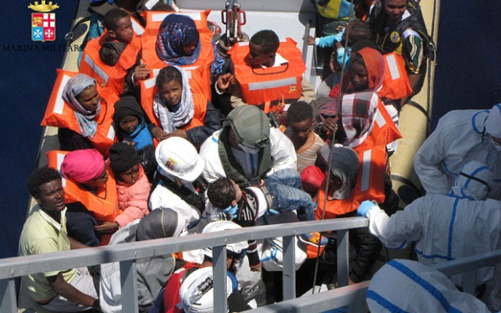
Baby born to migrant mother at sea hours after Italian navy rescue

Pregnant mother among 6,500 migrants

rescued in Mediterannean in last

48 hours doing well after giving birth

to healthy baby girl
By Nick Squires, Rome 4:39PM BST 04 May 2015

A newborn baby girl was one of thousands of migrants brought ashore in Italy as a political row broke out over how to accommodate the ceaseless exodus of refugees streaming across the Mediterranean from Libya.
The baby was born on board an Italian navy ship, the Bettica after her mother, who is Nigerian, was rescued from a boat floating off the coast of Libya on Monday.
The Italian navy, which released a photograph of the tiny girl swaddled in a white cloth, said both she and her mother were in good health.
In total, the Bettica rescued 654 migrants from four different boats, all of them sent from the coast of Libya by smuggling gangs, who are making tens of millions of pounds from trafficking desperate people fleeing war and poverty in the Middle East and Africa.
“The mother was brought on board in dramatic circumstances – her labour had already started,” the navy said in a statement.
The baby was delivered by Sara Modde, a doctor with the Order of Malta, a Catholic charity that has teams of medics on board many of the search and rescue vessels operating in the Mediterranean.
The mother and her baby were among 6,770 migrants who were rescued in the Mediterranean in the space of just three days.
Vincenzo Pascale, the captain of the Italian navy ship on which the baby was born, said: "She is a beautiful baby girl who has touched everyone on board. The mother started to have contractions as soon as she was brought aboard and gave birth after eight hours.
"We made a little crib and put it next to the mother, who was worn out by the labour," he told Italian media.
Not all of them survived the crossing. Seven dead bodies were found aboard two large rubber dinghies packed with migrants, while the corpses of three others were pulled from the water.
They had apparently jumped or fallen into the sea when they saw rescue vessels approach.
Smugglers had packed people into the boats so tightly that they were unable to move their legs and many were suffering from cramp, humanitarian groups said.
The search and rescue is being carried out by the Italian navy and coast guard as well as ships acting on behalf of Frontex, the European border control agency, and merchant vessels.
The EU pledged to strengthen the operation last month after a migrant boat sank with an estimated 750 people on board, including women and children.
http://www.telegraph.co.uk/news/worldnews/europe/italy/11581553/Baby-born-to-migrant-mother-at-sea-hours-after-Italian-navy-rescue.html

Migrant Woman on a Melbourne Tram
by Jennifer Strauss
Impossibly black
Amid the impudence of summer thighs
Long arms and painted toenails
And the voices
Impossibly obscure
She hunches sweltering
Twists in sweating hands
A scrap of paper — address, destination,
Clue to the labyrinth
Where voices not understood
Echo
Confusing directions.
(There was a time
They sent them out of Greece
In black-sailed ships
To feed the minotaur.
Whose is the blind beast now
Laired in Collingwood,
Abbotsford, Richmond,
Eating up men?)
Street-names in the glare
Leap ungraspably from sight
Formless collisions of letters
Impossibly dark
She is forlorn in foreign words and voices,
Remembering a village
Where poverty was white as bone
And the great silences of sea and sky
Parted at dusk for voices coming home
Calling names
Impossibly departed
http://www.poetrylibrary.edu.au/poets/strauss-jennifer/migrant-woman-on-a-melbourne-tram-0696010#

